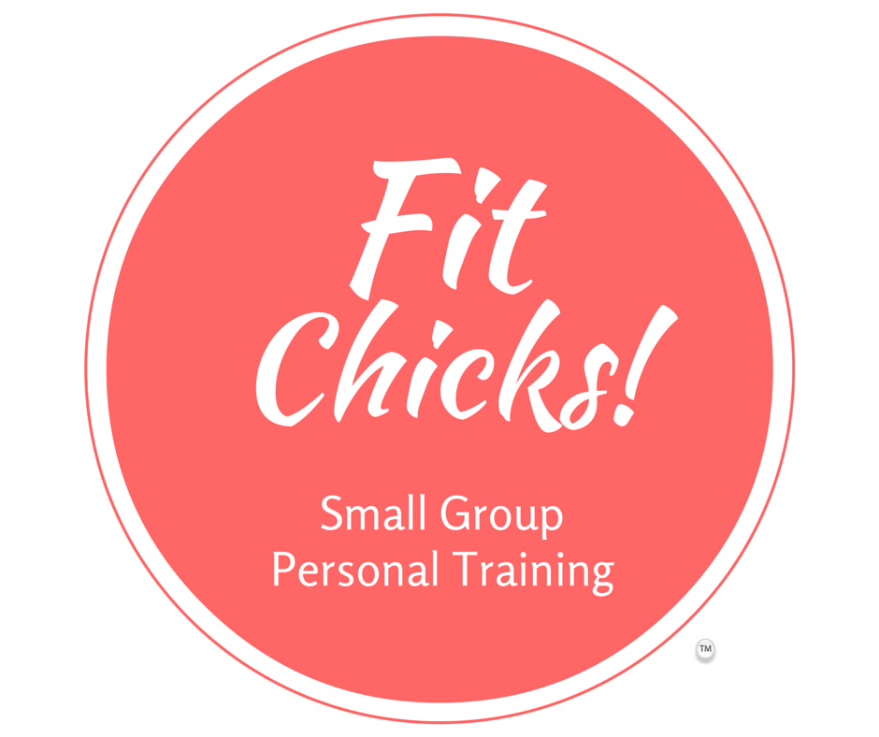

You Watched It or Read It!
Now Tell Us…

- What did you like best? Or was your biggest take-away?

- What’s one thing you disagreed with or found too challenging?

- What’s one thing you want to do differently based on the video or book?

